Analysis of the competitive situation

One of the most important thing for a company is profit. In order to have a good view over the profitability of the company, the analysis of the competitive situation is very important. Moreover, this analysis can help the company to make use of the features of the market and to influence them.

The company was established 2010 and gained success year by year. Now, the total number of clients is over 800 and is continuously rising.

**Buyer power** is a very important factor the can affect the DIGIROM company and put it under loads of pressure. In order to reduce **buyer power**, the company came up with a loyalty program. Furthermore, no massive price changes took place. Last, but not the least, the company offers the latest technologies reducing the availability of **substitute services** from the competitors, thus reducing one more time the **buyer power**.

Our company has a big **rivalry** with the existing competitors, but because it is originated from this area, the people choose to place their trust in this local company and not in the foreign ones. This also happened because DIGIROM provides good services at reasonable prices. DIGIROM also has an innovative advertising strategy, for example: footsteps on the pavement leading to the company office.

The **threat of new competitors** is a real problem which can reduce the market attractiveness and the profit of our company. In order to avoid this thing, DIGIROM offers a wide range of services that can be adapted for every customer’s wishes. This also differentiate them from the competition and reduce the **threat of substitution.**

From its establishment, the company succeeded in building its name becoming a local brand.

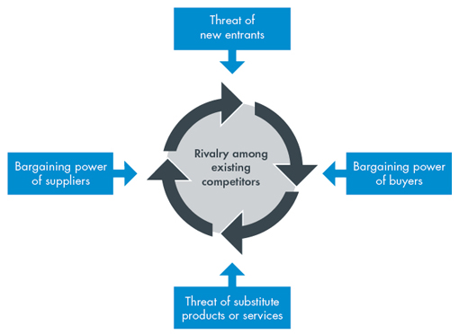

**Porter’s five forces**